AKS

* **FQDN**: Fully Qualified Domain Name: AKS’s DNS prefix is an FQDN
* **Virtual nodes**: deploy or burst containers to nodes backed by serverless Azure Container Instances (fast burst scaling options beyond AKS cluster size)
* AKS Total Cores: Nodes * CPU per each node

Connect to Kubernetes via CLI:

1. **az aks get-credentials –-resource-group XNZYASD –-name aksclustername**
2. **kubectl get nodes**
3. **DEPLOY STUFF: kubectl apply –f azure-vote.yaml**
4. **Kubectl get service**

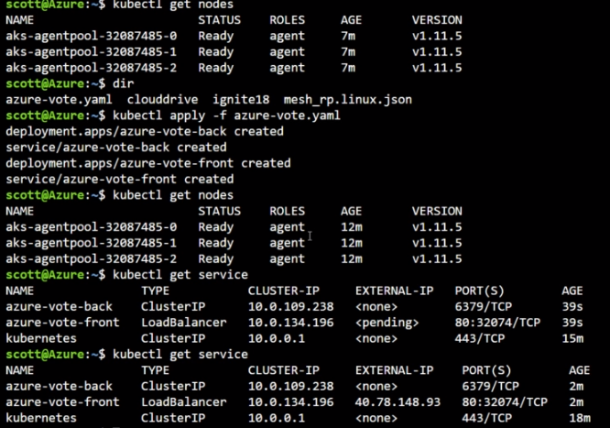

* **az aks install-cli**
  + update a PATH variable
* az login
* az aks get-credentials - -resource-group - -name
* az aks browse - -resource group - - name
  + creates web server locally (:8001), dashboard for kubernetes

**docker-compose up –d** (boom, its now running)  
opposite: *docker-compose down*

**docker-machine ip Default** (IP where its deployed)

**Azure Container Registry:** store images